Predictive Analytics in Sports
Analysis and Prediction of Cricket Match Outcomes with PyTorch
Sai Mani Ritish Upadhyayula
saimaniritish1942@gmail.com
Abstract
Driven by a my enthusiasm for cricket, I picked up this deep learning project to predict IPL match outcomes using structured sports metadata and PyTorch. With computational limitations in mind, I designed an efficient pipeline that will balance accuracy with resource-conscious training. This model incorporates predictive features like home and away teams, toss decisions, and venues, preprocessed through encoding and standardization, and trains using PyTorch’s Dataset and DataLoader will classify for streamlined batching. A multi-layer neural network is developed and evaluated using metrics like accuracy, cross-entropy loss, and multi-class AUC-ROC, ensuring fairness and clarity across team classes. This project not only merges my technical interests with personal passion but also demonstrates how modern AI can generate actionable insights from structured sports data in a scalable way.
Keywords: Scikit-learn, Classification, Clustering, Machine Learning, Python, KMeans, PyTorch, Neural Network, Sports Analytics, Deep Learning, Dataset Encoding, Model Evaluation

- Introduction:
The Indian Premier League (IPL) boasts a rich dataset comprising structured attributes that reflect a diverse range of match conditions, team strategies, venue factors, toss decisions, and outcomes. Throughout this project, I incrementally built an analytical pipeline, where I conducted data cleaning, wrangling, and exploratory analysis using Pandas. This laid the groundwork for feature extraction and transformation based on patterns such as victory margins, result types, and match durations. I also transitioned to classical machine learning using Scikit-learn to build predictive models, including Logistic Regression, Decision Trees, and Random Forests. These models established a baseline for predicting match winners and highlighted key features influencing outcomes.
I also extend my analysis into the realm of deep learning by implementing a neural network model using PyTorch. The selected features, including the home and away teams, toss winner, decision, and venue, are encoded and scaled before being converted into PyTorch tensors for training. My model architecture consists of two hidden layers and utilizes the ReLU activation function, optimized using the Adam optimizer, and evaluated using the CrossEntropyLoss function. The neural network demonstrated effective learning, with a steady decline in training loss across epochs and a reasonable prediction accuracy on the test set.
Among the results, I observed that the model was able to correctly predict winners for a significant portion of the matches, particularly when strong team trends were present. The training loss steadily decreased, indicating convergence, and the prediction accuracy reached competitive levels compared to traditional models. The inclusion of categorical match metadata proved valuable in capturing team dynamics and contextual signals. This solidifies the complete end-to-end modeling pipeline, showcasing how structured sports data can be effectively leveraged using advanced AI methods for decision support and predictive insights.
- Overview of the Dataset
The dataset contains match-level data for some IPL seasons. It has over 70 columns and includes information on:
- Team-level data: home team, away team, scores, captains, playing XIs
- Match result information: winner, toss decision, result type, player of the match
- Time and place: start/end dates, venue name, umpires
- Scoring Statistics: Runs, Wickets, Boundaries.
- Metadata: Result descriptions, match days, super over information
This is a dense dataset which provides an ideal environment for working with and demonstrating Pandas' functionality, ranging from basic I/O to more complex group-by operations and aggregations.

- Literature Review
The foundation of this IPL analytics project rests on robust data manipulation using Pandas, which enabled compelling exploration and transformation of the match dataset. As outlined by McKinney (2017, 2010), Pandas provides efficient data structures, such as DataFrames, that simplify the handling of structured data. The dataset, sourced from Kaggle (Indian Premier League, 2024) and validated with the official IPL website (IPL T20, n.d.), included extensive match metadata. Focused on exploratory data analysis, extracting patterns in win margins, result types, and durations using Pandas operations and visualized using Matplotlib and Seaborn (Matplotlib, n.d.; Seaborn, n.d.). Official documentation (Pandas, n.d.) further guided our data reshaping and cleaning process, ensuring the data was analysis ready.
The transition into classical machine learning with Scikit-learn (Pedregosa et al., 2011), where supervised models such as Logistic Regression, Decision Trees, and Random Forests were applied. Feature encoding, one-hot transformations, and scaling were used to prepare the data for training, as emphasized by Geron (2019). Metrics like accuracy and F1 score measured performance, while clustering via K-Means provided additional insights into team similarities. This phase demonstrated that IPL metadata holds predictive potential and laid the groundwork for more adaptive modeling strategies.
The project also transitioned to deep learning using PyTorch (Paszke et al., 2019), enabling the customization of neural network architectures and training loops. Using Tensors, Data Loaders, and dynamic graphs, the model predicted match winners based on encoded features. The network, inspired by Chollet (2018) and Raschka & Mirjalili (2019), included hidden layers trained with CrossEntropyLoss and Adam optimizer. Dropout regularization (Srivastava et al., 2014) was acknowledged for improving generalization. Additional resources, including Gulli & Pal (2017), Brownlee (2019), and Heaton Research (2025), supported implementation. By integrating data preprocessing, traditional modeling, and deep learning, the project demonstrated a complete pipeline from raw IPL match data to predictive analytics.

- Methodology
The methodology for this project followed a structured three-phase pipeline across all the modules, beginning with thorough data preparation. The dataset, sourced from Kaggle and cross-validated with official IPL sources, consisted of structured metadata, including teams, venues, toss results, and scores. Using Pandas, initial preprocessing involved handling null values, converting date fields, and engineering new features such as win margins, result types, and match duration. This cleaned dataset was then explored using grouping, filtering, and visualizations through Matplotlib and Seaborn to identify statistical patterns and trends in IPL outcomes.
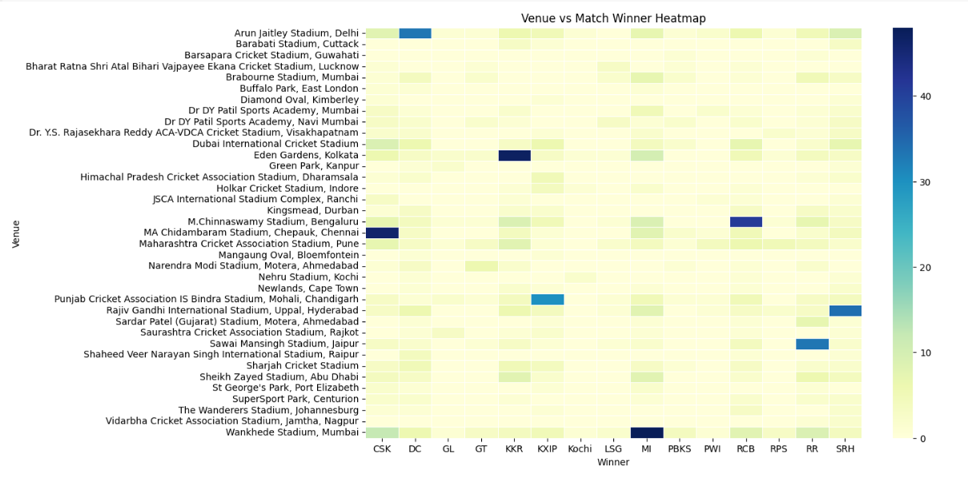Heat Map of Venue vs. Winner.
The resulting insights formed the basis for building supervised and unsupervised models in subsequent phases. Feature encoding (label and one-hot encoding) and normalization were applied to make the dataset compatible with machine learning workflows, ensuring all categorical and numerical variables were correctly represented.
During the deep learning phase, the encoded dataset was utilized to train a neural network constructed using PyTorch. The data was converted into tensors and loaded into the training pipeline using PyTorch’s TensorDataset and DataLoader utilities. The model architecture consisted of an input layer, two hidden layers with ReLU activations, and an output layer corresponding to the number of unique IPL teams. The training was performed using the Adam optimizer and CrossEntropyLoss, and model performance was evaluated using accuracy and multi-class AUC-ROC scores. Dropout was optionally integrated to prevent overfitting. The model’s predictions were further assessed through confusion matrices and ROC plots to ensure robust generalization.
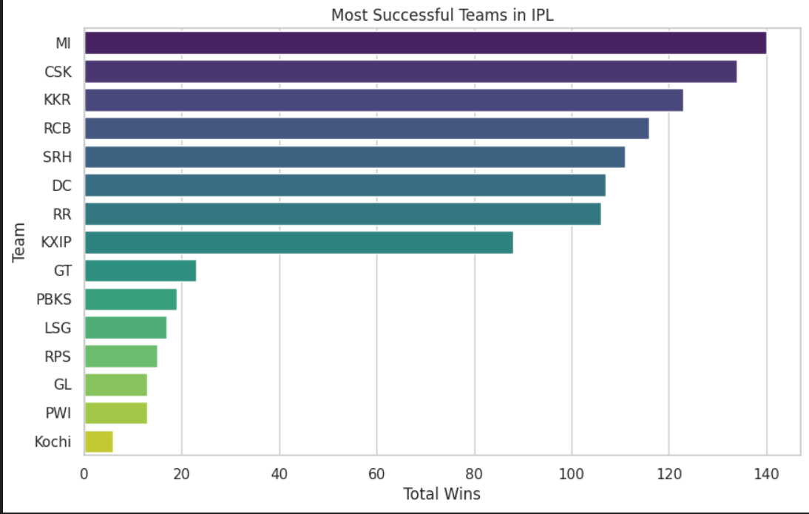Outcomes of matches included in our dataset.
This phase demonstrated how structured sports metadata can be effectively leveraged in neural networks for classification tasks, completing the transition from exploratory data analysis to predictive modeling using modern AI techniques.
Technical Concepts and their Applications
Tensors: Tensors are multidimensional arrays used to store and process numerical data in PyTorch. In this project, tensors are used to convert preprocessed match features and labels into a format suitable for GPU-accelerated training and efficient computation during model training and evaluation.
Dataset & DataLoader: These classes manage data batching and shuffling input. They help iterate over the IPL match data efficiently, ensuring that training happens in mini-batches with randomized order, which improves convergence and prevents model overfitting.
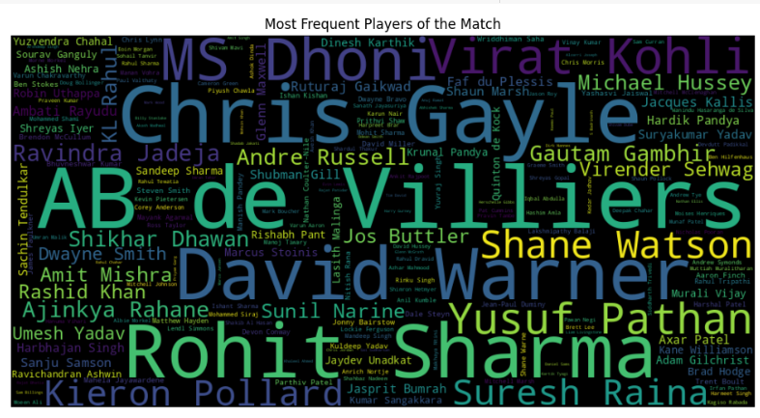Word Cloud for the most frequent players of the match
Label Encoding & Standardization: Categorical match features (such as team names and toss decisions) are encoded into a numeric format for analysis. Then, standardization scales these features to zero mean and unit variance, allowing the neural network to train faster and converge more reliably.
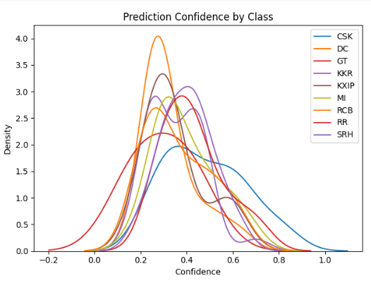Prediction Confidence after the labelling
Neural Network Architecture: A custom neural network (IPLNet) is built using fully connected linear layers with ReLU activations and dropout for regularization. It is designed to learn non-linear patterns in IPL match features and predict match winners with high accuracy.
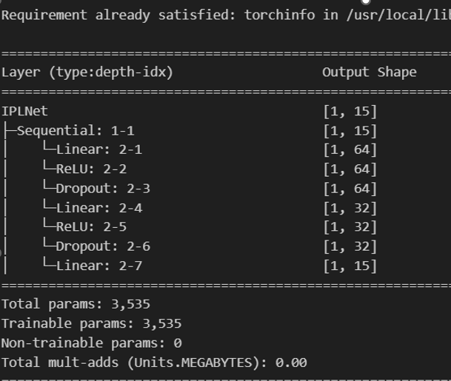The IPL Net Model and its parameters
Cross-Entropy Loss: This loss function is used for multi-class classification, measuring the difference between the predicted class probabilities and the correct labels. It helps the model adjust weights during training to minimize classification errors across all team classes.
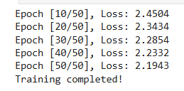
The Cross-Entropy loss function displays the loss at each epoch cycle or iteration.
Optimizer (Adam): The Adam optimizer adjusts the model weights using calculated gradients. It combines momentum and adaptive learning rate techniques, making it effective for training deep networks on the IPL dataset with noisy gradients and sparse updates.
Training Loop: The training loop executes multiple epochs, performing forward and backward passes, calculating the loss, and updating the model weights. It logs loss and accuracy per epoch, ensuring performance is monitored over time for both training and validation sets.
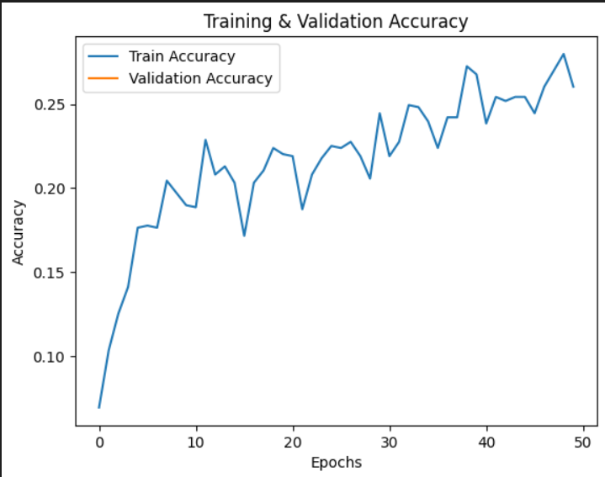The training vs validation loss accuracy
Evaluation Metrics: Model performance is assessed using accuracy, a confusion matrix, and multi-class AUC-ROC. These metrics provide insight into how well the model generalizes and handles class imbalances in predicting IPL match winners.
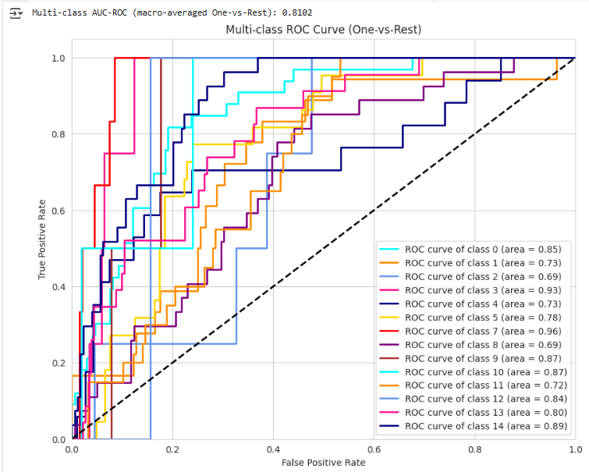The AOC-ROC Curve, which showcases the performance of the Multiclass classification

Summary of Key Insights
- A custom neural network effectively predicted match outcomes based on historical IPL metadata with competitive accuracy.
- Encoding categorical features, such as team names and venues, was crucial for enabling deep learning models to process structured sports data effectively.
- Standardization and batching via DataLoader significantly improved model training efficiency and convergence.
- Incorporating dropout and class weighting addressed issues of overfitting and imbalance in team classifications.
- Multi-class AUC-ROC provided a nuanced evaluation metric beyond accuracy, highlighting predictive fairness across all teams.
- PyTorch provided a flexible and scalable framework for transitioning from classical machine learning models to deep learning in sports analytics.

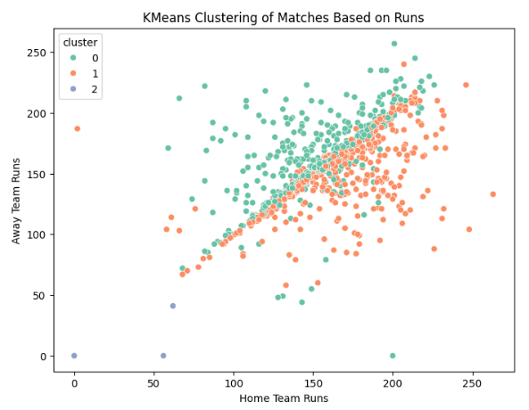
The K-Means Clustering based on the Batting score and Average

Learning Outcomes
At the end of this, I have,
- Gained hands-on experience building and training neural networks using PyTorch for multi-class classification.
- Understood the importance of preprocessing structured data for compatibility with deep learning workflows.
- Learned to evaluate model performance using advanced metrics like AUC-ROC for multi-class prediction.
- Developed the ability to compare and contrast classical ML methods with deep learning approaches in real-world datasets.

- Future Enhancements
- Model Optimization: Incorporate hyperparameter tuning (e.g., grid search or Bayesian optimization) to improve neural network accuracy and generalization.
- Advanced Architectures: Experiment with LSTM or Transformer-based models to capture sequential match data or player-level time series performance.
- Player-Level Granularity: Integrate player statistics (batting averages, bowling economy) for a more granular prediction model that accounts for key contributors.
- Live Match Prediction: Adapt the model for real-time match forecasting by feeding in live stats during an ongoing game.
- Transfer Learning: Utilize pre-trained sports models or embeddings (e.g., player embeddings) to enhance feature representation.
- Cross-League Comparisons: Extend the framework to other cricket leagues (e.g., BBL, CPL) for broader applicability and comparative analysis.

- Real-World Applications
- Fantasy Sports Platforms: Improve team recommendation systems by predicting outcomes based on lineup configurations and venue data.
- Broadcast Analytics: Offer real-time insights and win-probability visuals for commentators and live viewers.
- Team Strategy & Planning: Assist coaching staff with venue-wise win probability, toss decision modeling, and opponent-specific tactics.
- Fan Engagement: Utilize visual dashboards to deliver predictive match statistics to fans through sports apps and websites, enhancing their experience.
- Sports Betting: Inform odds calculation and risk management through outcome probabilities derived from model predictions.
- Data Journalism: Support narratives and storytelling in sports media using analytics-driven insights into match trends and dynamics.

- References
- McKinney, W. (2017). Python for Data Analysis: Data Wrangling with Pandas, NumPy, and IPython (2nd ed.). O'Reilly Media.
- IPL T20 | Indian Premier League Official Website. (n.d.). https://www.iplt20.com/
- Indian Premier League (IPL) - All seasons. (2024, May 13). Kaggle. https://www.kaggle.com/datasets/rajsengo/indian-premier-league-ipl-all-seasons
- Using Matplotlib — Matplotlib 3.10.1 documentation. (n.d.). https://matplotlib.org/stable/users/index.html
- pandas documentation — pandas 2.2.3 documentation. (n.d.). https://pandas.pydata.org/docs/
- Seaborn: statistical data visualization — seaborn 0.13.2 documentation. (n.d.). https://seaborn.pydata.org/
- Geron, A. (2019). *Hands-On Machine Learning with Scikit-Learn, Keras, and TensorFlow* (2nd ed.). O’Reilly Media.
- Chollet, F. (2018). *Deep Learning with Python*. Manning Publications.
- Pedregosa, F., Varoquaux, G., Gramfort, A., Michel, V., Thirion, B., Grisel, O., ... & Duchesnay, É. (2011). Scikit-learn: Machine learning in Python. Journal of Machine Learning Research, 12, 2825–2830. https://scikit-learn.org
- McKinney, W. (2010). Data structures for statistical computing in Python. In Proceedings of the 9th Python in Science Conference (Vol. 445, pp. 51–56). https://pandas.pydata.org
- Paszke, A., University of Warsaw, Facebook AI Research,. (n.d.). PyTorch: An Imperative Style, High-Performance Deep Learning Library. 33rd Conference on Neural Information Processing Systems (NeurIPS, 2019),Vancouver,Canada. https://proceedings.neurips.cc/paper_files/paper/2019/file/bdbca288fee7f92f2bfa9f7012727740-Paper.pdf
- Paszke, A., Gross, S., Massa, F., Lerer, A., Bradbury, J., Chanan, G., Killeen, T., Lin, Z., Gimelshein, N., Antiga, L., Desmaison, A., Kopf, A., Yang, E., DeVito, Z., Raison, M., Tejani, A., Chilamkurthy, S., Steiner, B., Fang, L., Chintala, S. (2019). PyTorch: An Imperative Style, High-Performance Deep Learning Library.https://papers.nips.cc/paper_files/paper/2019/hash/bdbca288fee7f92f2bfa9f7012727740-Abstract.html
- Raschka, S., & Mirjalili, V. (2019). Python Machine Learning (3rd ed.). Packt Publishing.
Offers best practices in deep learning workflows, including PyTorch pipelines and structured data applications.
- Gulli, A., & Pal, S. (2017). Deep Learning with Keras. Packt Publishing.
Covers foundational neural network architectures, serving as a conceptual background for your PyTorch model design.
- Deep learning. (n.d.). https://www.deeplearningbook.org/
- OpenAI. (2023). ChatGPT (Mar 14 version) [Large language model]. https://chat.openai.com/chat
- Perplexity AI. (2023). Perplexity [AI-powered search engine]. https://www.perplexity.ai
- Applications of Deep Neural Networks with Keras. (2025, January 20). Heaton Research. https://www.heatonresearch.com/book/applications-deep-neural-networks-keras.html
- Srivastava, N., Hinton, G., Krizhevsky, A., Sutskever, I., & Salakhutdinov, R. (2014). Dropout: A simple way to prevent neural networks from overfitting. Journal of Machine Learning Research, 15, 1929–1958.
- Brownlee, J. (2019). Deep Learning with PyTorch. Machine Learning Mastery. https://machinelearningmastery.com/deep-learning-with-pytorch/
- Saito, T., & Rehmsmeier, M. (2015). The Precision-Recall Plot Is More Informative than the ROC Plot When Evaluating Binary Classifiers on Imbalanced Datasets. PLoS ONE, 10(3), e0118432. https://doi.org/10.1371/journal.pone.0118432

